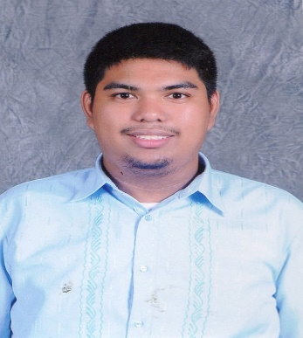

VICTOR PAUL J. DELA CRUZ
Contact number: 09556685299
E-mail address: victorpauldelacruz@gmail.com

CAREER OBJECTIVE

To seek a challenging task to meet my competencies, capabilities, skills and education.

PERSONAL INFORMATION

Nationality: Filipino

Religion: Roman Catholic

Home Address: Block 4 Lot 2, Darluz Subdivision, Santo Tomas, Davao del Norte

Birthdate: August 5, 1995

Gender: Male

ELIGIBILITY DATE OF RELEASED
Career Service Professional May 27, 2016
Civil Service Commission

Licensure Examination for Professional Teachers January 9, 2020
Professional Regulation Commission

CURRENTLY EMPLOYED DATE OF DURATION
Davao del Norte State College August 2021 to Present
New Visayas, Panabo City, Davao del Norte

PREVIOUSLY EMPLOYED DATE OF DURATION
Maryknoll College of Panabo, Inc, June 2016 to March 2018
National Highway, Panabo City

TRAININGS/SEMINARS

Basics in LaTeX and RMarkdown April 12-13, 2022
Mindanao State University- Iligan Institute of Technology
Via Zoom

Virtual Training-Workshop Series on Disease Modelling March 23, 2022
With Numerical Simulations March 30, 2022
Caraga State University April 20, 2022
Butuan City
Via Zoom

Webinar Workshop on Designing Interactive October 27 to 29, 2021
And Engaging Strategies in Managing Synchronous
and Asynchronous Classes for Remote Learning:
Continuing Initiative for Coursepack Development
Davao del Norte State College
Panabo City, Davao del Norte
Via Zoom

Webinar-Training on Bayesian Statistics: Very Easy Practical October 15,2021
Bayesian Statistics for Biology Teachers and Biology Students
University of Southeastern Philippines
Davao City
Via Zoom

Training on Scientific Writing and Publication October 6 to 7, 2021
Davao del Norte State College
Panabo City, Davao del Norte
Via Zoom

Hands on Data Analysis 101 Training December 8, 2017
Sagingrepablik
Davao City, Philippines

Big Data Analytics Workshop November 25, 2017
AMA Computer Learning Center
Davao City, Philippines

AFFILIATED ORGANIZATIONS

Philippine Association for Teachers and Educators
Member

Philippine Statistical Association, Inc.
Regular Member

AUTHOR

Probability and Statistics Grade 11
Diocesan Printing Press and Publishing, Inc.
Diocese of Tagum Educational System

Basic Calculus
Diocesan Printing Press and Publishing, Inc.
Diocese of Tagum Educational System

EDUCATION Year Graduated

Elementary: Maryknoll High School of Sto. Tomas 2008
Sto. Tomas, Davao del Norte

Secondary: Maryknoll High School of Sto. Tomas 2012
Sto. Tomas, Davao del Norte

Tertiary: University of Southeastern Philippines 2016
Davao City
Bachelor of Science in Statistics

North Davao Colleges, Inc.
Panabo City, Davao del Norte
Secondary Education Earner

Post-Tertiary: University of Southeastern Philippines 2022 Davao City
Master of Science in Applied Mathematics

Short Course: John Hopkins University 2018-2019
Reproducible Research
Exploratory Data Analysis
Getting and Cleaning Data
R-Programming
Data Scientist’s Toolbox

SKILLS/SPECIALIZATIONS

- Knowledgeable in Data Science and Data Analysis
- Interpreting of statistical results in Time Series Analysis, Experimental Design, Multivariate Analysis, Categorical Data Analysis, and Linear Regression and Correlation Analyses in the field of Education, Social Sciences, Aquatic Sciences, and Economics
- Knowledgeable in validating the questionnaire
- Knowledgeable in the use of Statistical Software for Social Sciences (SPSS), JASP, R Statistical Software, Epi Info, Minitab and STATA
- Knowledgeable in Microsoft Word, Excel and PowerPoint
- Knowledgeable in Prezi, and R Markdown
- Hardworking, discipline, prompt and well-organized
- Willing to work under pressure

